EASY!APPOINTMENTS BACKEND DOCUMENTATION

Documentation by Jesse Hyde

FAQ

How to Create Administrator and Add Company 2

How to Set Up Calendar Working Days 3

How to Set Up Working Day Hours 4

How to Set Up Service Categories 6

How to Set Up Services 7

How to Set Up Staff 9

How to Set Up Secretaries 11

How to Set Up Admins 13

How to Delete The Following: (Service Categories, Services, Staff, Secretaries, Admins) 15

If choosing for Service Categories: 15

If choosing for Services: 16

If choosing for Staff: 17

If choosing for Secretaries: 17

If choosing for Admins: 18

If choosing for Customers: 18

How to Edit the Following: (Service Categories, Services, Staff, Secretaries, Admins) 20

If choosing for Service Categories: 20

If choosing for Services: 21

If choosing for Staff: 22

If choosing for Secretaries: 22

If choosing for Admins: 23

If choosing for Customers: 23

How to Change Company Name 25

How to Change Company Email 26

How to Change Company Link 27

How to Create and Display Cookie Notice 28

How to Create and Display Terms & Conditions 29

How to Create and Display a Privacy Policy 30

How to Display a Staffs Calendar 31

How to Display a Services Calendar 32

How to Change Time Format 33

How to Change Date Format 34

How to Change Book Advance Timeout 35

# How to Create Administrator and Add Company

Upon opening Easy!Appointments for the first time, the user will be prompted to the administration page. Fill in the required fields with your relevant information to create a administrator. Fill in the required fields with your relevant information to add your Company.

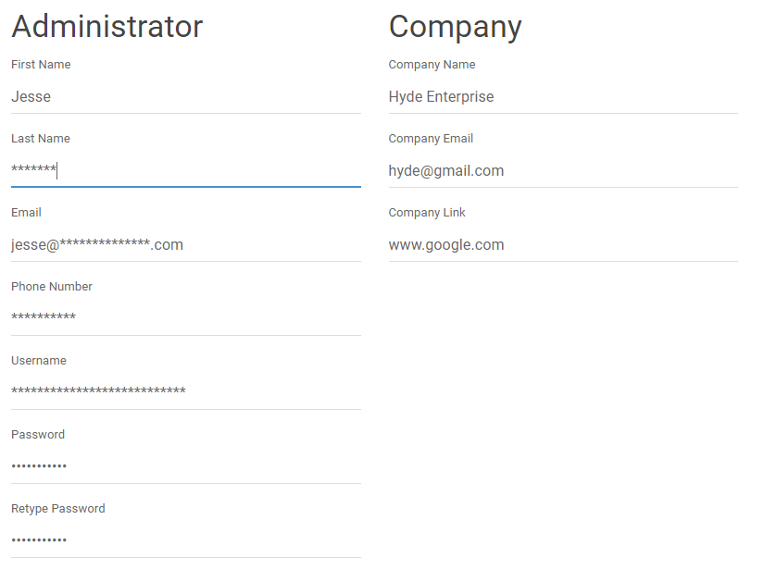

Click ‘Install Easy!Appointments’ to proceed to the backend.

# How to Set Up Calendar Working Days

1. Click ‘Settings’ tab in top right of page.
2. Click ‘Business Logic’ tab.

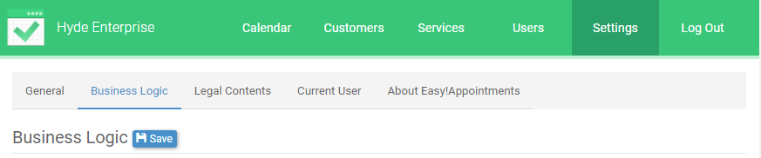

1. Tick and/or un-tick the days your company works

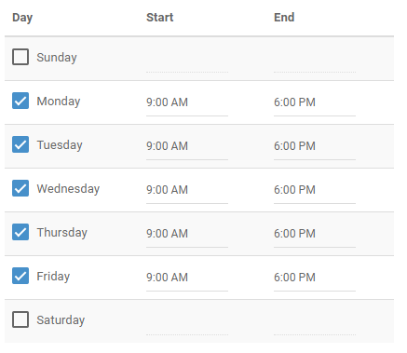

1. Click the ‘Save’ button near heading ‘Business Logic’



# How to Set Up Working Day Hours

1. Click ‘Settings’ tab in top right of page.
2. Click ‘Business Logic’ tab.



1. Click on Start or End time within the Working Plan table.
2. In the pop up box click ‘Now’ to select your current time. Other wise drag the sliders to your choice of hour and minute.
3. Click ‘Close’ to save.

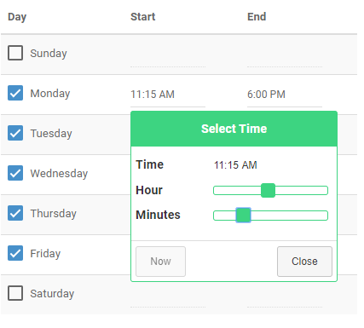

1. Repeat.
2. Click the ‘Save’ button near heading ‘Business Logic’



# How to Set Up Service Categories

1. Click ‘Services’ tab at top of page.
2. Click ‘Categories’ tab.

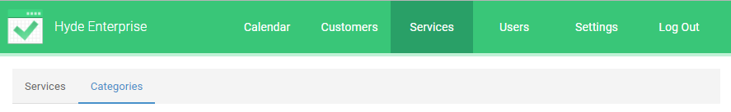

1. Click ‘+Add’ to enable fields for editing.



1. Fill in fields about your category.

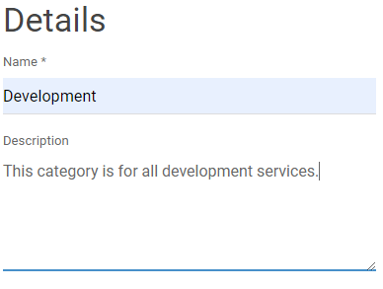

1. Click ‘Save’.



1. Repeat for all categories within your business.

# How to Set Up Services

1. Click ‘Services’ tab at top of page.

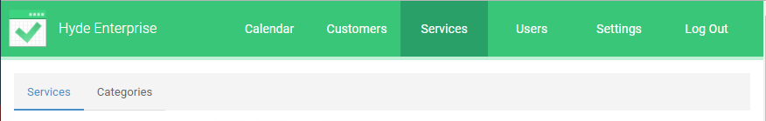

1. Click ‘+Add’ to enable fields for editing.



1. Fill in fields about your service.

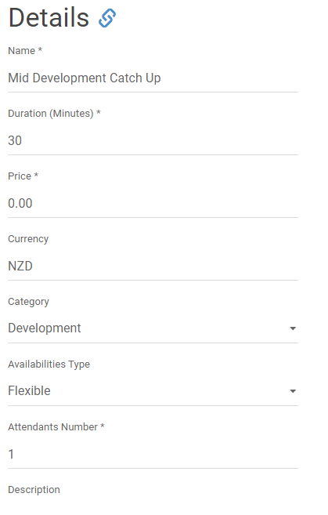

1. Click ‘Save’.



1. Repeat for all services within your business

# How to Set Up Staff

1. Click ‘Users’ tab at top of page.



1. Click on ‘Providers’ tab.



1. Click ‘+Add’ to enable fields for editing.



1. Fill in fields with relevant information for one staff member.

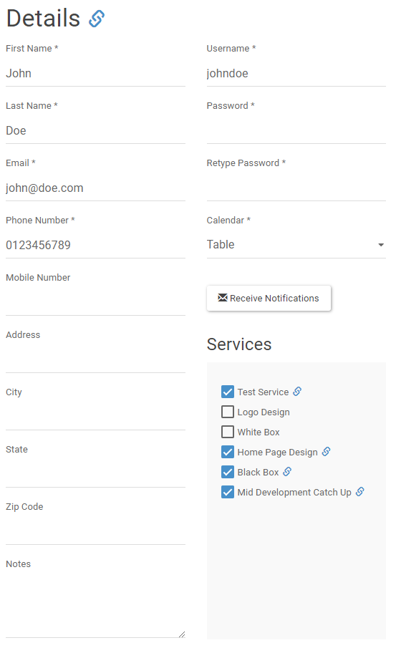

1. Click ‘Save’.



1. Repeat

# How to Set Up Secretaries

1. Click ‘Users’ tab at top of page.



1. Click on ‘Secretaries’ tab.



1. Click ‘+Add’ to enable fields for editing.



1. Fill in fields with relevant information for one secretaries.

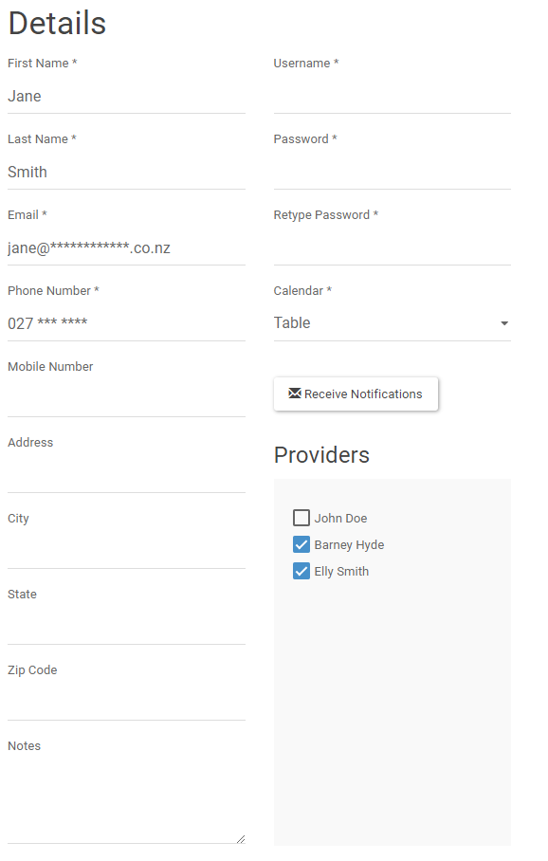

1. Click ‘Save’.



1. Repeat

# How to Set Up Admins

1. Click ‘Users’ tab at top of page.



1. Click on ‘Admins’ tab.



1. Click ‘+Add’ to enable fields for editing.



1. Fill in fields with relevant information for one admin.

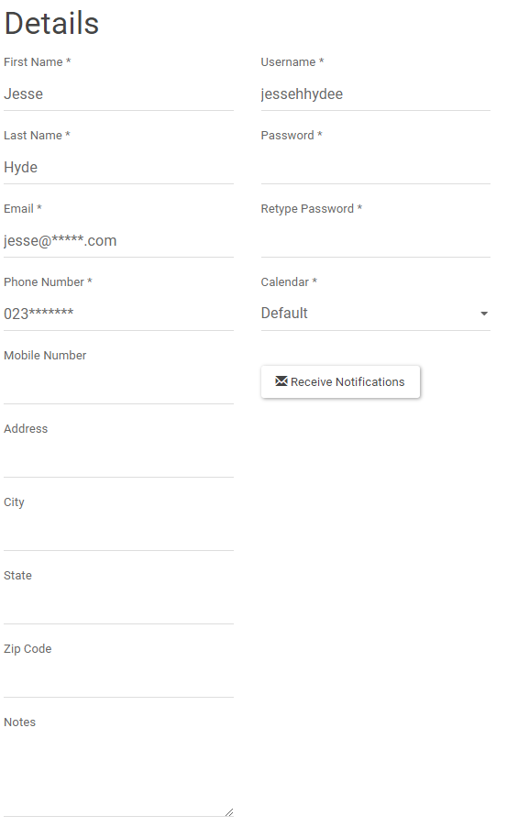

1. Click ‘Save’.



1. Repeat

# How to Delete The Following: (Service Categories, Services, Staff, Secretaries, Admins)

## If choosing for Service Categories:

1. Click ‘Services’ tab at top of page.
2. Click ‘Categories’ tab.



1. Select category from left hand side of page.

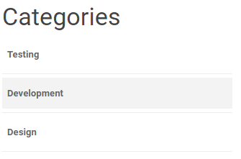

## If choosing for Services:

1. Click ‘Services’ tab at top of page.



1. Select service from left hand side of page.

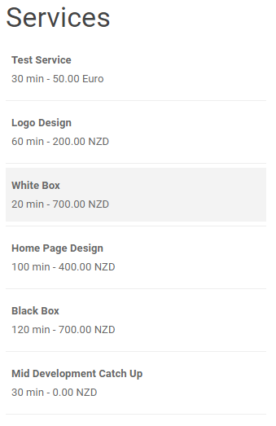

## If choosing for Staff:

1. Click ‘Users’ tab at top of page.



1. Click on ‘Providers’ tab.



1. Select staff member from left hand side of page.

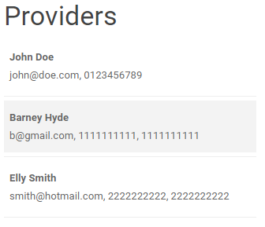

## If choosing for Secretaries:

1. Click ‘Users’ tab at top of page.



1. Click on ‘Secretaries’ tab.



1. Select secretary user from left hand side of page.

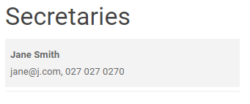

## If choosing for Admins:

1. Click ‘Users’ tab at top of page.



1. Click on ‘Admins’ tab.



1. Select admin user from left hand side of page.

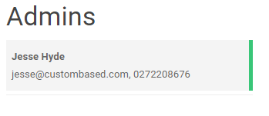

## If choosing for Customers:

1. Click ‘Customers’ tab at top of page.



1. Select customer from left hand side of page.

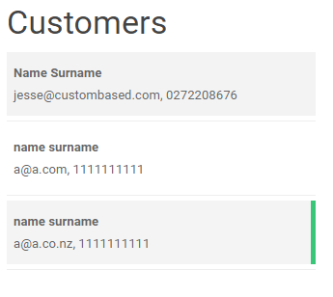

1. Click ‘Delete’ button.



1. Click ‘Delete’.

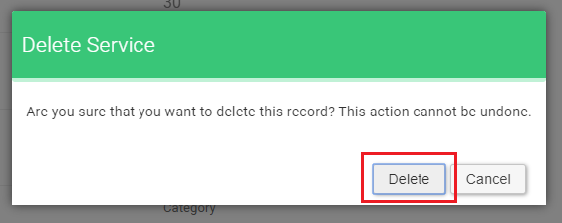

# How to Edit the Following: (Service Categories, Services, Staff, Secretaries, Admins)

## If choosing for Service Categories:

1. Click ‘Services’ tab at top of page.
2. Click ‘Categories’ tab.



1. Select category from left hand side of page.



## If choosing for Services:

1. Click ‘Services’ tab at top of page.



1. Select service from left hand side of page.



## If choosing for Staff:

1. Click ‘Users’ tab at top of page.



1. Click on ‘Providers’ tab.



1. Select staff member from left hand side of page.



## If choosing for Secretaries:

1. Click ‘Users’ tab at top of page.



1. Click on ‘Secretaries’ tab.



1. Select secretary user from left hand side of page.



## If choosing for Admins:

1. Click ‘Users’ tab at top of page.



1. Click on ‘Admins’ tab.



1. Select admin user from left hand side of page.



## If choosing for Customers:

1. Click ‘Customers’ tab at top of page.



1. Select customer from left hand side of page.



1. Click ‘Edit’ button and change what is required.

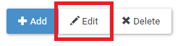

1. Click ‘Save’.



# How to Change Company Name

1. Click on ‘Settings’ tab at top of screen.

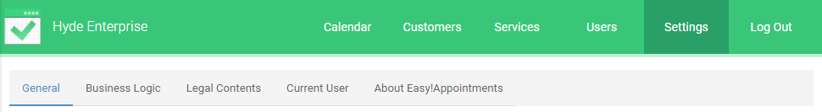

1. Under the default opening of the ‘General’ tab, click on the ‘Company Name’ field.
2. Remove company name and change to new company name.

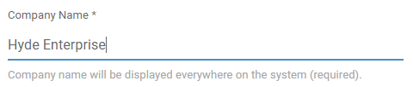

1. Click the ‘Save’ button.



# How to Change Company Email

1. Click on ‘Settings’ tab at top of screen.



1. Under the default opening of the ‘General’ tab, click on the ‘Company Email’ field.
2. Remove company email and change to new company email.

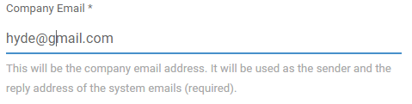

1. Click the ‘Save’ button.



# How to Change Company Link

1. Click on ‘Settings’ tab at top of screen.



1. Under the default opening of the ‘General’ tab, click on the ‘Company Link’ field.
2. Remove company link and change to new company link.

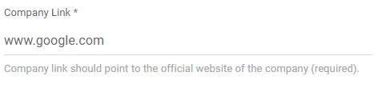

1. Click the ‘Save’ button.



# How to Create and Display Cookie Notice

1. Click on ‘Settings’ tab at top of screen.
2. Click on ‘Legal Contents’ tab.

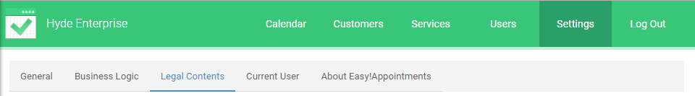

1. Tick ‘Display Cookie Notice’.
2. Enter cookie notice that you would like to display. There is a range of options to choose from along the top of the text area to customize your text.

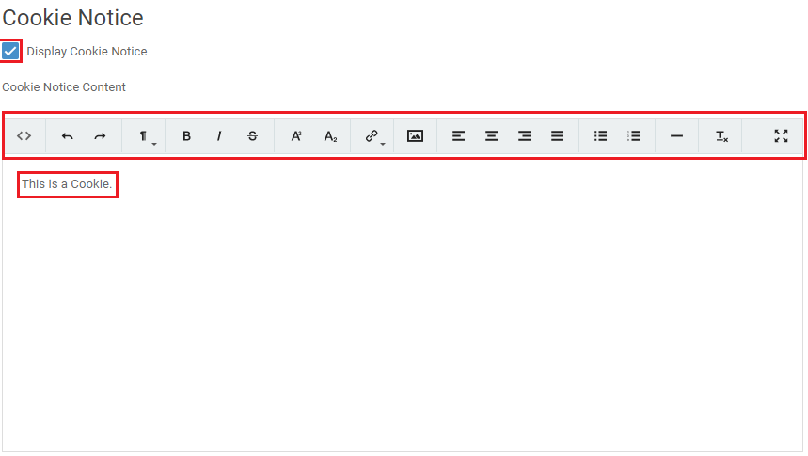

1. Click the ‘Save’ button.



# How to Create and Display Terms & Conditions

1. Click on ‘Settings’ tab at top of screen.
2. Click on ‘Legal Contents’ tab.



1. Scroll down page and tick ‘Display Terms & Conditions’.
2. Enter terms & conditions content that you would like to display. There is a range of options to choose from along the top of the text area to customize your text.

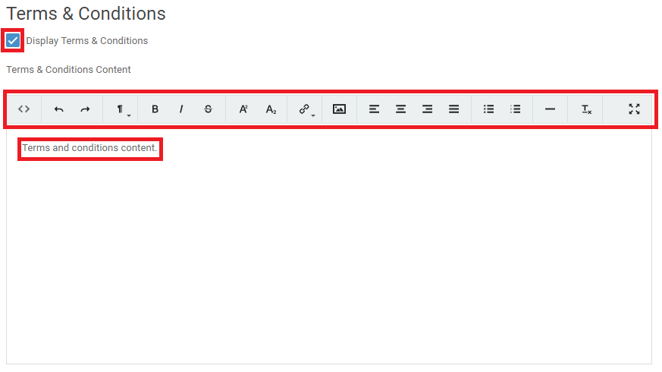

1. Click the ‘Save’ button.



# How to Create and Display a Privacy Policy

1. Click on ‘Settings’ tab at top of screen.
2. Click on ‘Legal Contents’ tab.



1. Scroll down page and tick ‘Display Privacy Policy’.
2. Enter privacy policy content that you would like to display. There is a range of options to choose from along the top of the text area to customize your text.

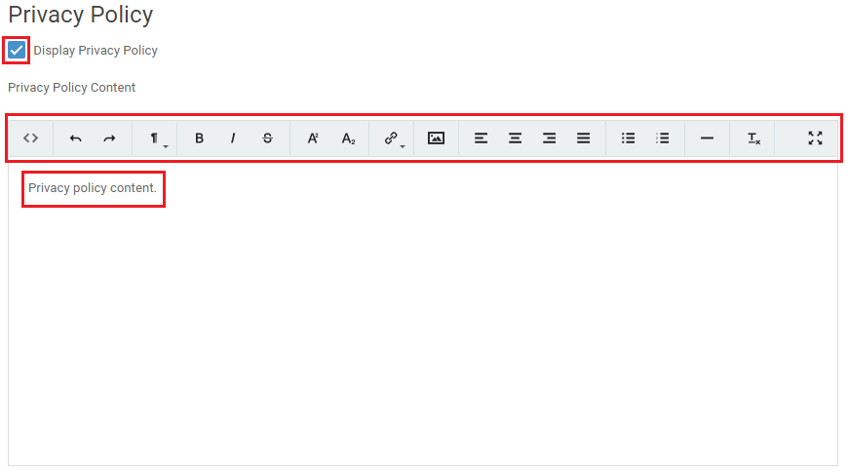

1. Click the ‘Save’ button.



# How to Display a Staffs Calendar

1. Click on ‘Calendar’ tab at top of page.



1. Click on the ‘Display Calendar’ dropdown menu.
2. To select staff member, choose your required member under the providers heading within the dropdown menu.

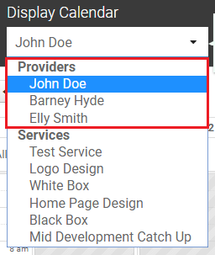

# How to Display a Services Calendar

1. Click on ‘Calendar’ tab at top of page.



1. Click on the ‘Display Calendar’ dropdown menu.
2. To select service, choose your required service under the services heading within the dropdown menu.

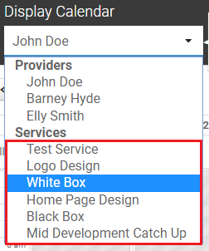

# How to Change Time Format

1. Click on ‘Settings’ tab at top of screen.



1. Under the default opening of the ‘General’ tab, click on the ‘Time Format’ dropdown menu.
2. Choose preference from dropdown menu.

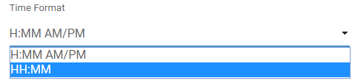

1. Click the ‘Save’ button.



# How to Change Date Format

1. Click on ‘Settings’ tab at top of screen.



1. Under the default opening of the ‘General’ tab, click on the ‘Time Format’ dropdown menu.
2. Choose preference from dropdown menu.

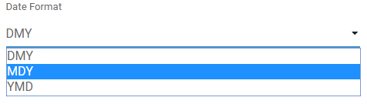

1. Click the ‘Save’ button.



# How to Change Book Advance Timeout

1. Click ‘Settings’ tab in top right of page.
2. Click ‘Business Logic’ tab.



1. Under the ‘Book Advance Timeout’ heading, either type in your chosen time or use the up and down arrows to select a time.

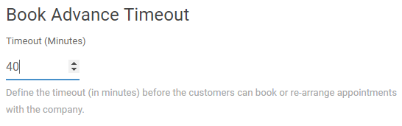

1. Click the ‘Save’ button near heading ‘Business Logic’.

